A1025-Mex-Mayan-Jaina Island-Male-Ceramic Figurine-Campeche Phase II-800-1000 CE

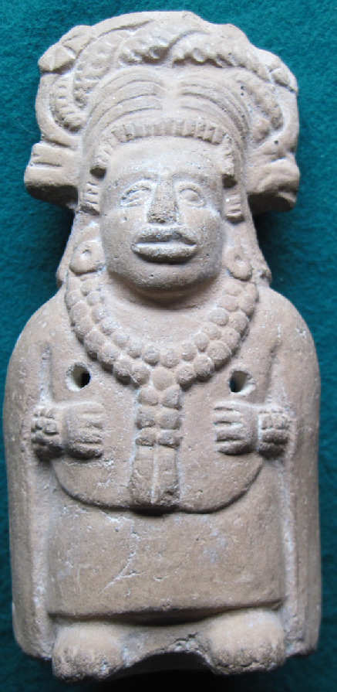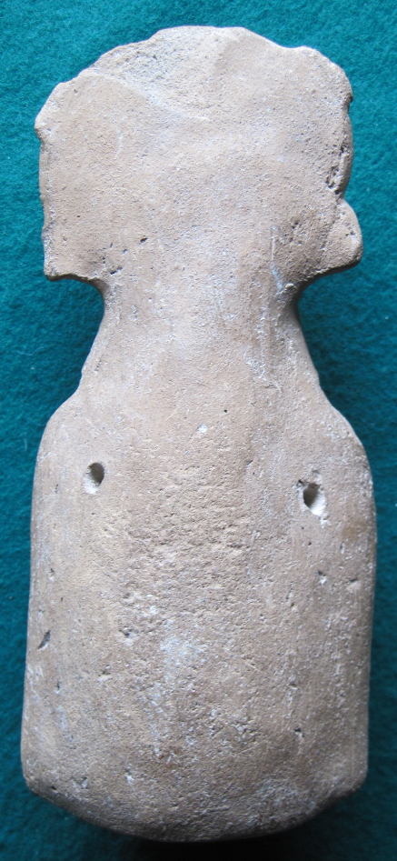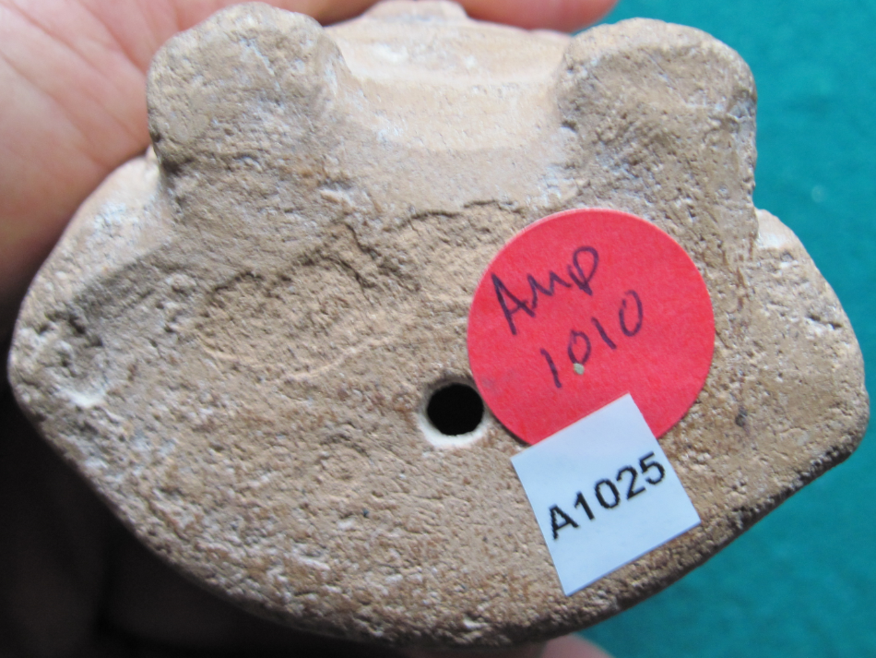

Figs 1-3. Mex-Mayan-Jaina Island-Male-Ceramic Figurine-Campeche Phase II-800-1000 CE

**Case no.: 10**

**Accession Number: A 1025**

**Formal Label:** Mex-Mayan-Jaina Island-Male-Ceramic Figurine-Campeche Phase II-800-1000 CE

**Display Description:**

This figurine of a male wearing a feather embellished headdress, ear spools, a bead necklace and a cuirass with a cape covering all is from an interment on Jaina Island and dates to the Campeche Phase II (1000-1200 CE) in which the figurines’ complex poses involving asymmetry is greatly reduced in favor of stiff frontal poses as in this example (Corson 1977: 67). Anatomical details such as the modelling of unique facial expressions is reduced in favor of a more standardized rendition attributable to mold-made figurines in which the arms, legs, face and headdresses were applied to the body in a solid mass. This figurine may have been manufactured in Veracruz or the Usumacinta River drainage. Holes that run from the front to the back (the interior is hollow) have allowed this figurine to be worn as a pectoral.

**LC Classification:** F1435.1.J3

**Date or Time Horizon:** Campeche Phase II-800-1000 CE

**Geographical Area:** Jaina Island

**Map, GPS coordinates:** 20.20750 -90.48389;40° 26' 46" N 79° 58' 56" W.

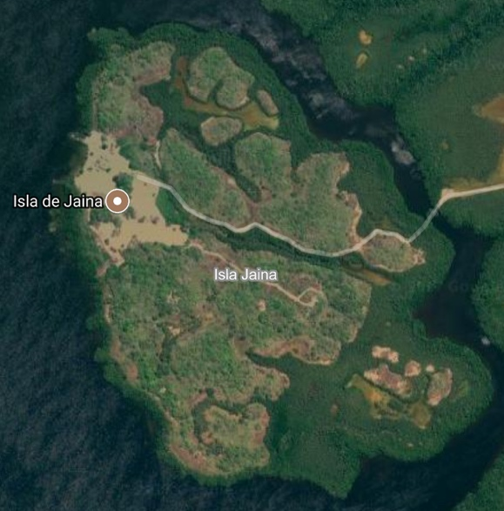 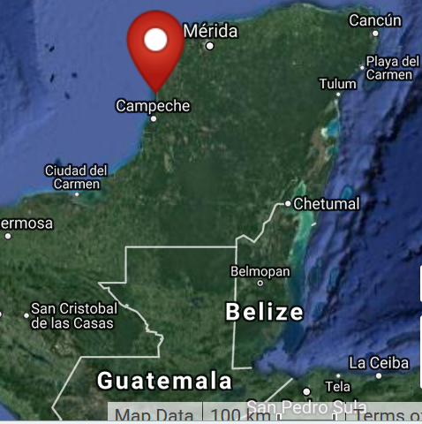

**Cultural Affiliation:** Campeche Phase II-800-1000 CE

**Medium: clay**

**Dimensions:** H 113.69 mm; 4.48 in

**Weight: 154 gm; 5 3/8 oz.**

**Condition: original**

**Provenance:** unknown.

**Discussion:**

Jaina Island, also known as "Temple in the Water" (Birmingham [Alabama] Museum of Art 2010: 85) is on the Yucatán Peninsula's limestone gulf coast and is separated from the mainland by a tidal inlet. It served as an élite Maya burial site where fine ceramic figurines were interred with the dead (Coe 1999: 143-144). Their place of manufacture was not necessarily on the island but could have been on the mainland extending along the coast of Campeche as this was the zone of marine trade and exchange.

Why was Jaina Island selected as the repository of so many mortuary figurines? The answer may lie in the *Popol Vuh* that proclaims all creation began in the sea: "Whatever there is that might be is simply not there; only the pooled water, only the calm sea, only it alone is pooled" (Tedlock 1985: 64). The Bearer and Begetter, who were in the water, created life. For the Maya both the beginning and the ending of humanity is in the waters to the west, and Jaina Island is one of the western-most islands off the coast of Campeche.

**References:**

[Birmingham [Alabama] Museum of Art](https://en.wikipedia.org/wiki/Birmingham_Museum_of_Art). 2010. [*Birmingham Museum of Art: guide to the collection*](http://artsbma.org). [Birmingham, Ala]: Birmingham Museum of Art.

Coe, Michael D. 1999. The Maya. 6th ed. New York: Thames & Hudson.

Corson, Christopher. 1973. "Iconographic Survey of some principal figurine subjects from the mortuary complex at Jaina, Campeche,” University of California Berkeley, Archaeological Research Facility, *Contributions* 18: 51-75.

Corson, Christopher. 1975. *Maya Anthropomorphic Figurines from Jaina Island, Campeche*.   
Ballena Press studies in Mesoamerican art, archaeology and ethnohistory, no. 1. Ramona, Calif.: Ballena Press.

Corson, Christopher. 1977 [1975]. “Stylistic evolution of Jaina figurines.” In Cordy-Collins, Alana and Jean Stern, *Pre-Columbian Art History: Selected Readings*. Palo Alto: Peek Publications, pp. 63-68. Previously published in the *Masterkey* (1975) 40:4.

Stone, Andrea, and M. Zender. 2011. *Reading Maya Art. A Hieroglyphic Guide to Ancient Maya Painting and Sculpture.* London: Thames and Hudson.

Tedlock, Dennis. 1985. *Popul Vuh. The Definitive Edition of the Mayan Book of the Dawn of Life and the Glories of Gods and Kings.* New York: Simon & Schuster.Sold by **[joeperadua](http://myworld.ebay.com/joeperadua" \o "view seller world, opens in new window or tab" \t "_blank)** ( [3478](http://feedback.ebay.com/ws/eBayISAPI.dll?ViewFeedback&userid=joeperadua) )

+ Show additional actions

### Delivery package 1 of 1

Estimated delivery **Tuesday, May 24, 2016** **- Friday, May 27, 2016**